Medical Consent Form for Medication Administration
Child’s Full Name: ___________________________ Date of Birth: _______________
Parent/Guardian Name(s): ___________________________ Date Completed: _______________
Section 1: Medication Details
Please complete for each medication your child may need during daycare hours.
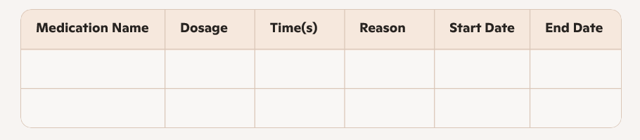
Form (check one): ☐ Liquid ☐ Tablet/Capsule ☐ Inhaler ☐ Topical ☐ Other: __________
Storage Instructions: __________________________________________
Special Instructions: __________________________________________
Section 2: Authorization & Consent
I authorize staff to administer the above medication(s) to my child as directed. I understand:
- Medication must be in its original container, labeled with my child’s name.
- Prescription meds require a pharmacy label with dosage and instructions.
- I will update the daycare with any changes.
- Staff will document each administration and notify me of concerns.
Signature: ___________________________ Date: _______________
Section 3: Emergency Contact & Physician Info
Emergency Contact Name: ___________________________ Phone: _______________
Physician Name: ___________________________ Phone: _______________
Clinic/Hospital: __________________________________________

